**The Top 10 Best Insurance Companies in Ghana**

Some people completely refuse to get insurance for many reasons, are you one of them? Insurance serves as protection for an individual against the loss of one’s property or an accident to one’s self which could pose a threat to your financial stability. Finding a good insurance company is key to success.

Insurance is a means of protecting oneself from loss. It’s a good way of risk management, and protects an individual from abrupt loss. There are several types of insurance for example, life insurance, property insurance and health insurance. There are several companies that offer insurance in Ghana, and guarantee safety for tomorrow, this article will look at the best ten of those companies.

1. **Enterprise Insurance Company**

The insurance company was founded in the year 1924 and is the oldest insurance company in Ghana. They have served the country since then through the provision of mouth-watering insurance packages. Their services are poised to assist their clients in managing their physical and financial loss as well as helping them secure their future.

Their branches are spread across the country and they are located at vantage points, putting them on the spotlight. The company is dedicated to also providing life-changing results to customers.

It offers life changing solutions for all its customers including insurance on properties, trustees and also funeral services. The enterprise is dedicated to improving lives by managing financial and physical loss. Their policies include; funeral plus plan, lifetime needs plus plan, educare plus plan, enhanced family income protection plan, ladycare plan, executive plus plan, living plus plan, akwantupa policy and many more.

Their vision is that in all their markets, their pedigree should be recognised, their strength respected, their expertise valued and their solutions sought by all who desire an advantage in life and their **mission is t**o provide all who come into contact with them, their desired advantage because they are the best at what they do. Their core values are friendliness, professionalism, trust, excellence and reliability.

CONTACT

**Location Address**Advantage Place,  
Mayor Road,  
Ridge West,  
Accra **Postal Address**Enterprise Group PLC  
PMB 150  
GPO  
Accra

[**+233 302 677073  , +233 302 634777**](tel:+233302677073)**,** [**+233554001924**](http://wa.me/233554001924)

[**info@enterprisegroup.com.gh**](mailto:info@enterprisegroup.com.gh)

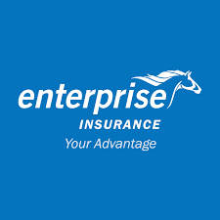

1. **State Insurance Company**

SIC was incorporated as State Insurance Corporation by Executive Instrument in 1962. SIC Insurance Company Limited is one of the oldest non-life insurance companies in Ghana.

SIC is a leading provider of general or non-life insurance products in Ghana. Its business operations cover fire, motor, marine and aviation, and accident insurance. SIC also provides specialty insurance products such as hoteliers and leisure policy, a policy for the hospitality industry.

With roots dating back to 1955, the Company has been operating for more than 52 years and has developed long-standing relationships with insurance brokerage firms and some independent agents, who constitute some of its primary distribution channels.  
  
SIC’s business is national in scope with a visible presence in all sixteen regions of Ghana. The Company has consistently, over the span of its business life, maintained steady market leadership. Currently, SIC holds approximately 23% of the insurance industry’s total market share. With about 14,000 shareholders on its platform, SIC is regarded as a major player in the provision of non-life insurance products.

They are well revered for their top-notch customer service and their professionalism in the field. For four years running it was adjudged, Insurance Company of the year by the CIMG. (Chartered Institute of Marketing, Ghana) (2003 – 2007). Currently, SIC is the highest independently rated Insurance Company in Ghana.

CONTACT

Head Office Address  
No. 28/29 Ring Road East  
Nyemitei House  
Adjacent UNDP Office  
P.O. Box 2363, Accra  
Tel. 233-302-780600-9  
Fax: 233-302-780615  
E-Mail: sicinfo@sic-gh.com  
Website: www.sic-gh.com

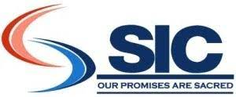

1. **Star life Assurance Company Limited**

Star Assurance Company Limited (“Star Assurance”), a member of the Star Assurance Group, is a privately owned Insurance Company incorporated in August 1984 and licensed to carry out corporate and retail insurance businesses in Ghana. It commenced in April 1985.

Star Life Limited is among the best life insurance companies in Ghana. It is dedicated to offer life assurance investment products to ensure that the needs of citizens are met accordingly.

StarLife Assurance Company Limited is a leading Life Assurance Company offering a wide range of need -based life assurance products designed to meet the financial security needs of the insuring public.

It was incorporated as a limited liability company in compliance with the new Insurance Law in October 2005, thus making it the first Life Assurance company to be separated as a composite Company.

StarLife Assurance has over the years delivered value added services to its valued clients making it one of the preferred Life Assurance companies in Ghana. It is no doubt that we are part of the top three life assurances companies in Ghana.

With a vision to be the pacesetters in creating wealth and a fulfilling life through personal relationships with our partners, a mission to help people identify the most secured wealth creation opportunities and to provide them with unique financial security solutions, it is certainly one of the best in Ghana. Their core values are; Integrity, Innovation, Leadership, Empathy, and Passion for Excellence.

Their products include individual products such as Family protection plan, Wealth Master plus, Supreme home call plan, Personal pension plan, Child lifeline plus and corporate products such as employee security plan, loan protection plan and mortgage protection plan.

CONTACT

No. 1 Mankata Avenue, Airport Residential Area  
P.O. Box AN 5783, Accra – North Ghana

Call on: +233 (0) 302 739600 / 0302739605

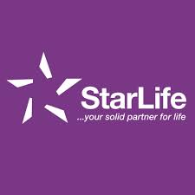

1. **Hollard Insurance**

The company was established in the year 1993 and they started their journey as Madison Insurance, which was renamed 4 years later to Metropolitan Insurance Company.

Hollard Ghana combines its deep local knowledge of the market with the world-class expertise of an international insurance brand. With their headquarters in South Africa but their feet firmly planted on Ghanian soil, they are able to deliver innovative insurance solutions that are customised to the unique risks you face.

The insurance company began all-around operations in the year 2015, after making moves to diversify into the provision of other commercial and personal products. The company now has offices in Kumasi, Tamale, Takoradi, and Tema.

Products rendered by the company are home insurance, personal accident, motor insurance, Indemnity, bonds, fidelity guarantee, engineering insurance, transit goods insurance, fire insurance, burglary insurance, travel insurance, executive insurance, and a host of others.

CONTACT

+233 302 220966

Physical Address:

11 Patrice Lumumba Road, Airport Residential Area

Postal Address:

P. O. Box GP 20084, Accra, Ghana

GPS Co-ordinates**:**

5.603026, -0.189267

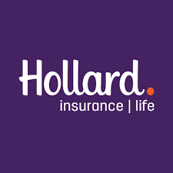

1. **Saham insurance**

Saham insurance now Sanlam is a Pan-African insurance group that offers a wide array of insurance related services including; life insurance, non-life insurance, reinsurance, and health insurance.

Saham Insurance Company is a limited liability insurance company. It acquired part of CNIA Assurance which was founded in Morocco in 1949 and has undergone a process of metamorphosis and growth where it now has a wide international network of 650 branches in 26 countries, including Ghana.

Their vision is to lead in the promotion of economic growth by providing the insuring public with secure, dynamic and professional services. Their key financial solutions include specialist risks such as property, marine, engineering and liability. Their success comes from their matchless technical expertise backed by Sanlam group with over 100 years of experience over the globe.

CONTACT

0302 228 047

care@gh.sanlam.com

Allied Heights, 2nd Floor, Olusegun Obasanjo Highway Abelemkpe - Accra

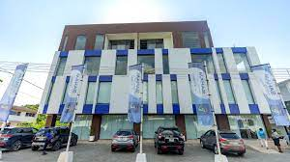

1. **Priority Insurance Company**

It is a wholly – owned Ghanaian Insurance company incorporated on the 8th day of September, 2011. Priority has been licensed by the National Insurance Commission to underwrite non-life insurance business in accordance with the provisions of the Insurance Law.

This is one of the most trusted insurance companies in Ghana and in the year 2014, they were rated as the 3rd fastest growing insurance company in the country.

The company has seven years of experience with specialized cutting-edge insurance product to suit your needs. They also maintain a class of competent and technical staff to handle all your insurance needs.

Products offered by the company range from motor insurance, transit goods insurance, indemnity, 3rd party liability, advanced loss of profits, business interruption, bonds, fire insurance, theft, marine insurance to construction insurance.

CONTACT

Priority Insurance Ltd.

PRIORITY HOUSEHse No: C502/1 Avenor Junction  
Adjacent C. Woermann (Ghana) Ltd.Kwame Nkrumah Circle to Carprice Road  
PMB CT 395, Cantonments, Accra – Ghana.Head Office Branch.  
0205719499 | 0553019060

E-MAIL: info@priorityinsuranceghana.net

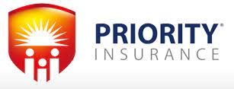

1. **Milife Insurance**

The company was established in the year 2005 and they are rated the 17th Life assurance company to be licensed by the National Insurance Commission (NIC).  In August 2017, the company was ranked the 8th most performing insurance firm in Ghana.

miLife focuses on providing, simple, affordable and more accessible life and savings insurance products to the mass market. The business provides educational, savings, funeral and term assurance policies. It also provides group life covers which offer protection for death, disability and critical illnesses.

They have branches spread across the country and with a capital of about GHS 57 million, the company is regarded as one of the most capitalized insurance firms in the country. The company utilizes mobile technology and uses its over 400 retail agency force to reach out to the mass market

Their vision is to be the leader in helping Ghanaians build their dreams, one customer at a time and their mission is to make insurance simple, affordable and more accessible, providing their customers and families with a smoother path to their dreams.

CONTACT

Mobile:[**024 243 9999**](tel:0242439999)

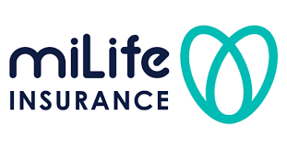

1. **Activa insurance company**

 It was incorporated in January 2005 and licensed to write short term general insurance business by the National Insurance Commission.  The parent company, Global Alliance climbed to the 9th position (out of 23 companies) in the Ghanaian insurance industry within four years of operation (2008).

Activa company is a member of the Pan- African insurance group. It is the 7th largest insurance company in Ghana. This company is licensed to offer insurance services. It ensures that customers are given the best insurance to cater for their needs accordingly.

Their products include marine insurance, personal accident, assets all risk, engineering insurance, professional indemnity and fire and allied perils.

CONTACT

Activa International Insurance Ghana

GA-050-0037, Ferguson Chapman Grant House

N.O 5 Farrar Avenue, Barnes Road,

Adabraka Accra, Ghana

[**Tel: + (233) 302 686 352**](tel:+233302686352)**,** [**Tel: +(233) 302 685 118**](tel:+233302685118)**,** [**Tel: +(233) 302 685 120**](tel:+233302685120)

[**info.gh@group-activa.com**](mailto:info.gh@group-activa.com)

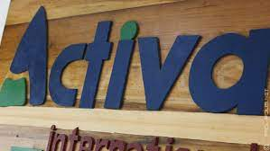

1. **Allianz Insurance company**

In December 2017, Allianz started its life insurance operations in Ghana with an official launch on 24th May, 2018. They offer a wide range of products for retail, SME and corporate customers, including Pure Life Insurance, Credit Life, Funeral, Education, Savings and Investments. They also offer micro insurance products for that segment of the population.

Allianz is an insurance company in Ghana owned by the Allianz group in Germany. The Allianz Group is one of the world's leading insurers and asset managers and is one of the world’s largest investors. In Africa, Allianz is currently present in 12 countries.

Allianz customers benefit from a broad range of personal and corporate insurance services, ranging from property, life and health insurance to assistance services to credit insurance and global business insurance

Their vision is to be Ghana's trusted brand, known to deliver real value to all stakeholders. With branches in Accra, Tema, Kumasi, Koforidu, Sunyani and Takoradi, they offer valuable services to their clients.

CONTACT

Allianz Ghana Head Office

Volta Place, 35 Patrice Lumumba Road,

Airport Residential Area (Accra)

600 meters from National Service Secretariat

PMB CT 353, Cantonments, Accra

Allianz Ghana:(+233) 308249090

Tel:[**(+233) 308249090**](tel:233302764891)

**Email:**[**customerservicegh@allianz.com**](mailto:customerserviceazgh@allianz.com)

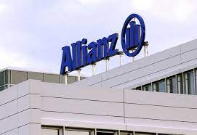

1. **Global Institute of Islamic Banking, Insurance and Consultancy Limited**

Global Institute of Islamic banking, Insurance & Consultancy or ‘GIIBIC’ is a leading independent organization dedicated solely in promoting and organizing investment services within Islamic banking, finance and halal sector in Ghana.

Located at Hall Avenue Adabraka, this esteemed insurance company is an international organization that offers the best insurance in Ghana. It provides room for consultancy and financial services necessary for risk management.

Their vision is to be a regional leader in provision of knowledge and consultant service in Islamic finance (banking, insurance and halal) sectors.

CONTACT

Tel: +233 322 494851. Mobile: +233 542014094.

WhatsApp: Tel: +233 542014094.

POSTAL ADDRESS  
Global Institute of Islamic Banking, Insurance & Consultancy  
Post Office Box KS 13757  
Kumasi Ghana

